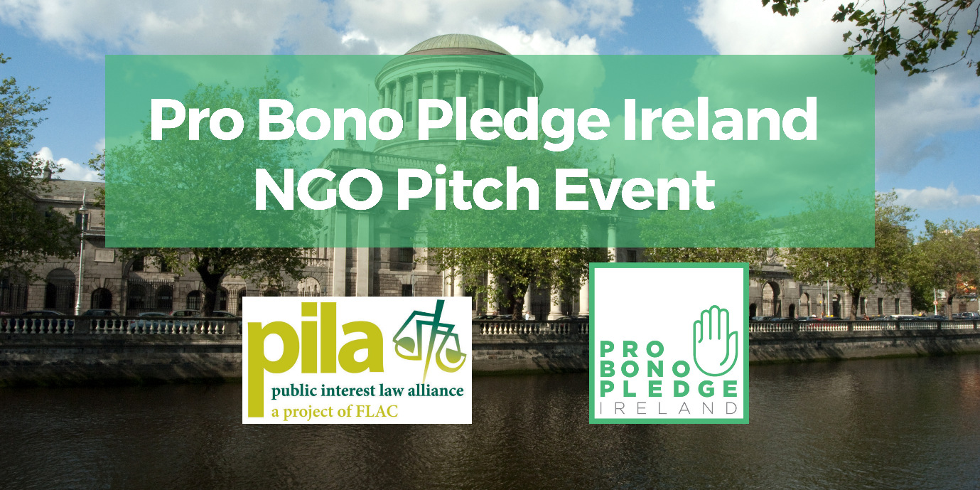
Applicant Organisation:
Address
Contact Name and Position in Organisation
Telephone
Email address
If the organisation is a registered charity, please include the registered charity number:
Has the organisation ever availed of PILA’s Pro Bono Referral Scheme in the past?
Brief details of the history, aims and objectives of the of the organisation:
Please provide a brief overview of how pro bono assistance could assist your organisation:

APPLICATION FORM MUST BE TWO PAGES ONLY. APPLICATIONS MORE THAN ONE PAGE WILL NOT BE ACCEPTED.
Application Process
Applications must be made on this NGO Pitch Event application form. The completed application form must be sent to PILA, no later than 31st May 2024. Please email all completed applications to pila@flac.ie with the subject line: NGO Pitch Event Application 2024.
Shortly after assessment, all applicants will be contacted and informed of the outcome.

